Calculus 1 Lecture 0.1: Lines, Angle of Inclination, and the Distance Formula

Lines:
To graph a line you need two point
Slope; how a line rises and falls

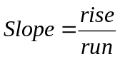

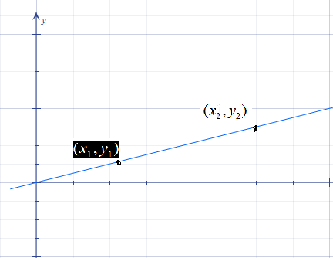

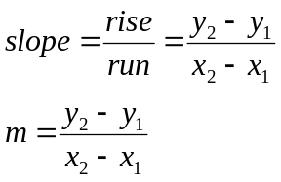
Fix a point and let the other point float
Manipulating the slope equation gives the point-slope line equation below
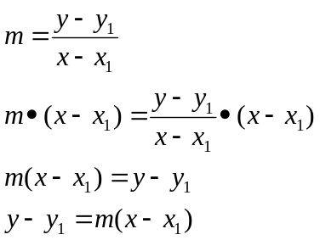

Example:
Find the equations of a line using the following points 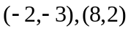

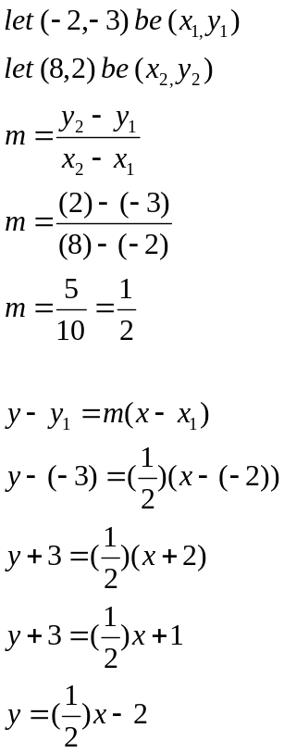
Slope Intercept line formula 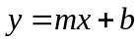
m=slope, b=y intercept

NOTES:
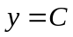, where C is a constant then you have a horizontal line
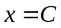, where C is a constant then you have a Vertical line

Example
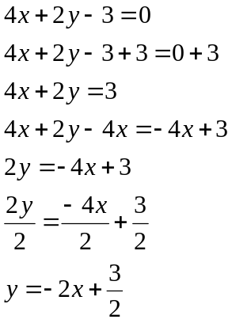

Parallel Lines:
Lines have the same slope

Perpendicular Lines:
Lines have slopes that are negative reciprocals of each other

Example
Find the equation through point (6,7) and parallel to 2x+3y=12
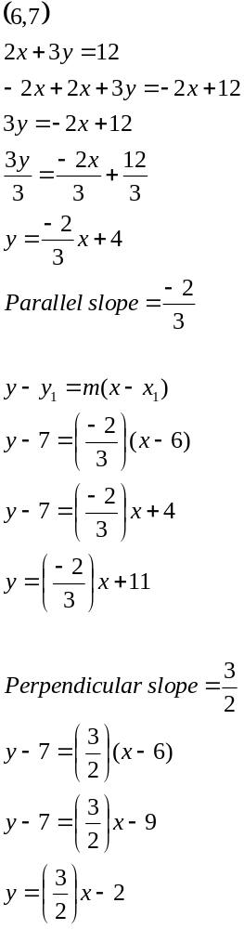

Angle of inclination:

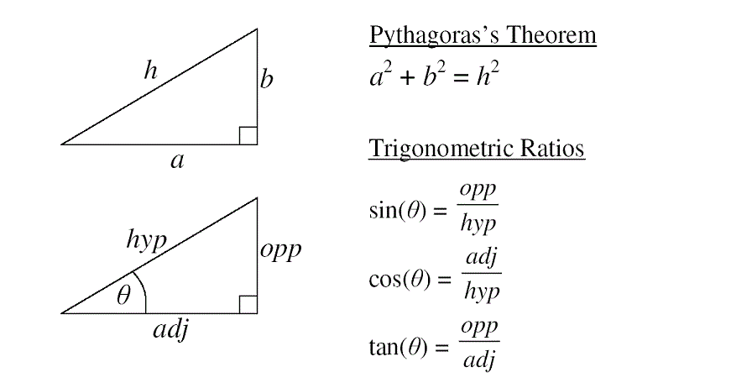

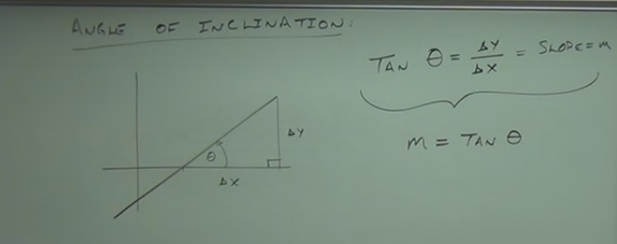

Radians to degrees
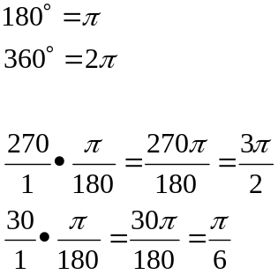

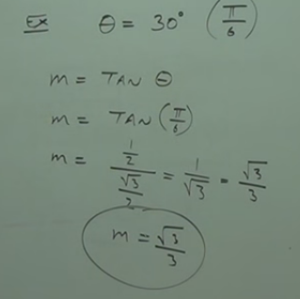

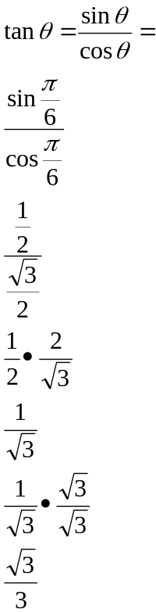

Find the angle given the slope of -1
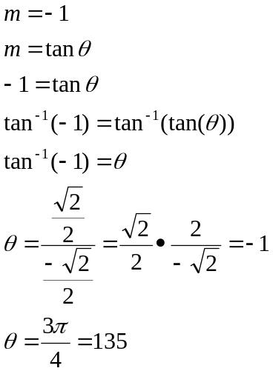

Distance formula
